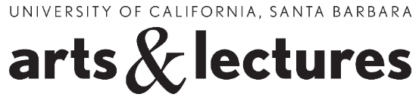
DIY Illustration Contest Submission Form

The DIY Illustration Contest is open to the public. We encourage people of all ages and abilities to submit an entry.

Deadline: Entries must be received by Tuesday, September 30 by 5 p.m. The winner will be announced on Thursday August 9 in The Santa Barbara Independent and/or on UCSB Arts & Lectures’ and The Santa Barbara Independent’s Facebook page(s).

Submission length: should be a comic strip of 1-5 frames or a testimonial of up to 200 words.

Submission type: should be a word doc, .pdf or .jpg.

Content: Items submitted for this contest should be your original creation and the content should be family-friendly.

Name ________________________________________________________________________________
Email Address _________________________________________________________________________
Phone Number ________________________________________________________________________
Submission Title _______________________________________________________________________
Are you a currently a student? If so, where? _________________________________________________

By submitting this form, I acknowledge that I have read and agree to the DIY Illustration Contest Rules and that (if under 18) my parent/guardian approves of my participation in this contest.

How to submit: Send your submission to contest@independent.com by September 30, 2014 at 5 PM.

Questions? Contact contest@independent.com

