A

Biological Approach

to the

Goleta Beach

Erosion Problem

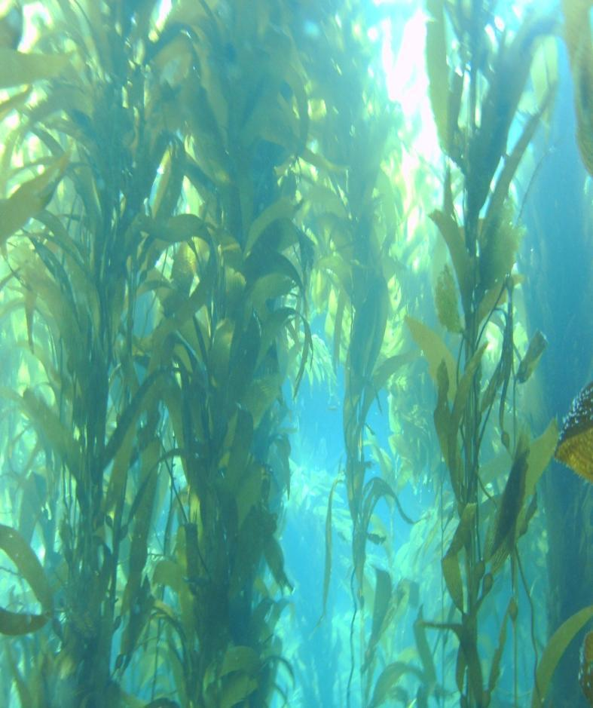

Goleta Bay

Sand-Dwelling

Kelp Bed

Restoration Project

Robert Kiel
October 10, 2010

Contents

Abstract iv
Introduction 1
Historical Observations 2
Figure 1: December 1979 2
Figure 2: Kelco 1972 Photo 2
Figures 4 & 5: Google Earth Images of Goleta 3
Figure 3: CDFG Kelp Beds #’s 21-31, Pre (A) & Post (B) 1982/’83 El Niño 3
Figures 6 & 7: Beach adjacent to UCSB 4
Figures 8 & 9: Santa Barbara News-Press Article, “Saving A Beach,” January 6, 2003 4
Questions 5
Hypothesis 5
Shoreline and Coastal Processes 6
Figure 10: Tajiguas during summer Figure 11: Tajiguas during winter 6
Figure 12: Sediment Samples 6
Figures 14 & 15: Dredged Fill, March 29, 2010 (left) and March 31, 2010 (right) 7
Possible Kelp Bed Influence 8
Figure 16: Model of Goleta Bay 9
Figure 17: Birds Resting Inside Goleta Bay 9
Kelp Bed Establishment Prior to 1982 10
Figure 18: Holdfast on Sand Bottom 10
Kelp Disappearance in Early 1980’s 11
Figure 19: Sandcastle Worms Colonizing Holdfast 11
Figure 20: UCSB beach, January 26, 1983 11
Sand-Dwelling Macrocystis Kelp 12
Figure 21: Diopatra ornata Worm Tube 12
Figure 23: Juvenile Sand-Dwelling Macrocystis Kelp Plant 12
Figure 22: Diopatra Congregating 12
Figure 25: Young Macrocystis Holdfast with Remnant of Diopatra ornata Worm Tube 13
Figure 24: Young Sand-Dwelling Kelp Plant on Beach. 13
Optimal Zone of Sand-Dwelling Kelp Beds 14
Investigative Dives in Goleta Bay 14
Link to Video Survey: 14
Proposed Strategy for Reestablishing Sand-Dwelling Kelp Beds 16
Figure 28: Holdfast Growing on Sand Bottom 17
Proposed Pilot Study 19
Purpose 19
Scope 19
Method 20
Link to Video showing water-jetting test in Goleta Bay: 20
Hypotheses to be tested 20
Figure 29: Google Earth Image with 1972 and 1975 Overlays 21
Google Earth Link 22
Future Large-Scale Project 23
Justifications for Reestablishing a Kelp Bed Offshore of Goleta Bay 24
Conclusion 25
Acknowledgements 25
References 26
Books 26
Papers 26
Contacts 29
Agencies Contacted 29
Businesses Contacted 31
Personal Contacts 31
Personal Contact Information 32

Abstract
The Goleta Beach Erosion problem began with the 1982/’83 El Niño event. Coinciding with this event was the disappearance of Macrocystis kelp from much of the Santa Barbara Channel mainland coastline. Kelp returned within the following couple of years where rock substrate exists, but the sand-dwelling kelp beds, which comprised the majority of kelp beds in the area (including Goleta Bay), have failed to recover to date and the beach inside Goleta Bay has remained in a chronically narrow state. Polarized views and on-going debate on how to treat the beach erosion problem have resulted in the expenditure of large amounts of time and money on the issues surrounding this problem. All strategies enacted or proposed to date have addressed only the symptoms of the problem. Empirically, a correlation between the kelp bed and beach form is apparent. Whether the two problems are effects of the same cause, or whether a cause/effect relationship exists between the kelp beds existence and beach width is debatable. Restoring the kelp bed to historical proportions would test these hypotheses, but the feasibility of doing so is unknown. Finding a suitable means of growing kelp on sand bottom would enable restoring the kelp bed in Goleta Bay to be considered as a possible ‘soft’ solution for addressing the erosion problem of Goleta Beach. This report explains a potentially viable means of doing so.

Introduction
Empirical evidence indicates there is a possible biological connection to the Goleta Beach erosion problem. Over 60 years of data supports the idea that a cause/effect relationship exists between the presence of an offshore kelp bed and the size of the beach in Goleta Bay. The effect this kelp bed may have had on altering the hydrodynamics of the bay is not fully understood, but it appears its presence may have influenced how and where beach-quality sand is transported and deposited.
Until the early 1980’s most of the Macrocystis kelp growing along the Santa Barbara mainland coastline grew on sand bottom, including offshore of Goleta Bay. Since the disappearance of these kelp beds, natural recovery has failed to occur.
The means by which kelp physically establishes itself on sand bottom requires the presence of structures to recruit onto and ideal oceanic conditions to get started. Lacking solid substrate to attach to, the individual plants have only sand from which to formulate an anchor. In order for a suitable anchor to develop, the holdfasts must be allowed the opportunity to grow large and fill with sand. Once established, these holdfast structures (referred to as growth-centers) ultimately become the anchoring systems of the plants comprising sand-dwelling kelp beds. Finding a viable means for aiding in the process of growth-center formation is the challenge.
Chronic erosion and a resulting narrow beach has persisted in Goleta Bay ever since the sand-dwelling kelp bed disappeared offshore in the early 1980’s. Aiding in the restoration of this kelp bed (and other sand-dwelling kelp beds) will require a number of criteria to be met. Performing a pilot study of a proposed method (described in this proposal) for growing kelp on sand bottom, will help in determining if it is feasible to do so on a large scale.
Restoring a kelp bed of historical proportions in Goleta Bay could conceivably provide a ‘soft’ solution to restoring a wide beach through natural processes, and would test the hypothesis that a biological approach to the Goleta Beach erosion problem exists.

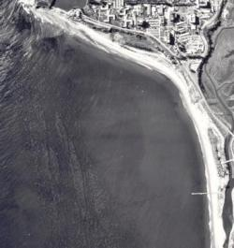
Historical Observations
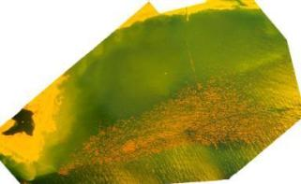
A wide beach formed naturally within Goleta Bay after Goleta Beach County Park was constructed in the mid-1940’s. Since that time the beach width, stability, and protection it provided to the park was evident (Fig’s. 1 & 2). This however began to change in the early 1980’s.

Figure 1: December 1979
Note kelp cutter tracks through the kelp bed and width of beach. Presence of vegetation along the backbeach by UCSB indicates relative stability of the beach over time.
Pacific Western Aerial Photos

Figure 2: Kelco 1972 Photo
California Department of Fish & Game (CDFG) kelp bed # 26.
Spliced slides by Greg Christman
Large kelp beds growing on sand bottom existed along the mainland coastline of the Santa Barbara Channel prior to the early 1980’s, including offshore of Goleta Bay. Having grown up in Goleta since 1961, this almost continuous band of kelp was a familiar sight to me.
The kelp beds were always a favorite of mine to explore. I recall searching for kelp beds growing on rock substrate, but often finding the kelp was growing only on sand bottom. The uniqueness of this phenomenon was not apparent to me at the time.
The kelp, which once grew along this stretch of coastline, disappeared from conditions associated with the 1982/’83 El Niño event (the largest and most severe in recent history). Kelp has since returned to areas where rock substrate exists, but the sand-dwelling kelp beds have failed to recover naturally. Consequently, there has been a 75% reduction in the amount of kelp between Gaviota and Summerland, according to surveys performed by the California Department of Fish and Game (CDFG – Fig. 3).

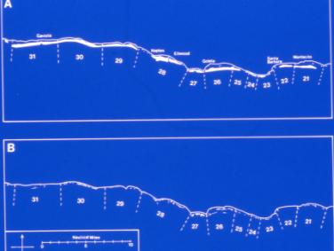

Figure 3: CDFG Kelp Beds #’s 21-31, Pre (A) & Post (B) 1982/’83 El Niño
Between Gaviota (Bed 31) and Summerland (Bed 21): A 75% reduction in kelp.

Following the disappearance of the kelp bed in Goleta Bay, the beach began to narrow and has remained in a chronically narrow state ever since (Fig’s. 4-7).

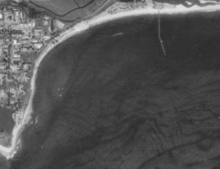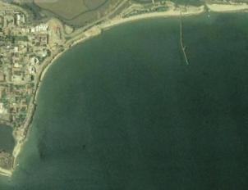
July 2004
September 1994

Figures 4 & 5: Google Earth Images of Goleta
Note narrow beach and absence of kelp bed.
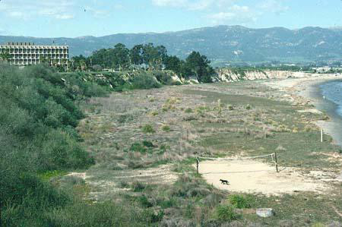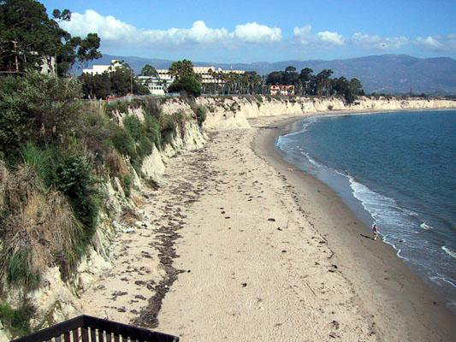
1972
2001

Figures 6 & 7: Beach adjacent to UCSB
The wide and stable beach (evident from the vegetation) in the left photo coincided with the existence of a kelp bed offshore. The right photo is typical of the beach form since the kelp bed was dislodged in the early 1980’s.
Photos taken by Dr. Arthur Gibbs Sylvester

A Santa Barbara News-Press article (Fig’s. 8 & 9: “Saving A Beach,” January 6, 2003) referenced a report by Moffatt & Nichol, which listed a series of ‘hard’ alternatives and beach nourishment as methods for restoring sand to Goleta Beach. The inferences made in this report compelled me to write a white-paper summarizing the possible effect a kelp bed in Goleta Bay may have had on altering coastal processes in a manner favorable to the natural accretion of sediment along the shoreline and the resulting formation of a wide beach.

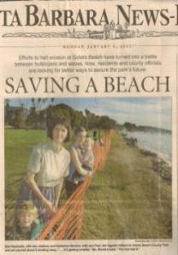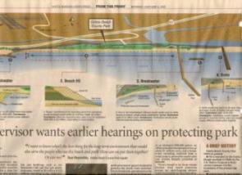

Figures 8 & 9: Santa Barbara News-Press Article, “Saving A Beach,” January 6, 2003

Questions
- Did the wide beach and large kelp bed coexist in Goleta Bay prior to 1982 because conditions were favorable to the formation of both, or did the kelp bed contribute to the formation of a wide beach?
- Why has the beach in Goleta Bay remained in a chronically narrow state since 1982?
- Why hasn’t the kelp bed offshore of Goleta Bay reestablished itself since its disappearance in the early 1980’s?
- Would reestablishment of the kelp bed offshore of Goleta Bay aid in the natural recovery of a wide beach inside the bay, and if so, how long would it take?
- Has there been a reduction in the delivery of beach-quality sand to the coast since 1982, or has there been a redistribution of sand along the shoreline in certain locations?
Answers to these questions should be sought in order to develop a comprehensive and ecologically-sound strategy for resolving the erosion problem of Goleta Beach.

Hypothesis
A change in current within Goleta Bay is the most likely explanation for the role a kelp bed might have had on affecting sediment transport. The size and location of the kelp bed created a boundary of resistance to water flow between the inner and outer waters east of Goleta Point. Since the kelp beds disappearance, I have often encountered current (always coinciding with wind) within the zone once occupied by the historical kelp bed. This primary current interacts with the body of water inside Goleta Point resulting in the formation of a secondary (eddy) current. These currents, coupled with normal wave and tidal activity, determine how sediment is transported and where it is deposited. Unless the offshore kelp bed is reestablished, existing coastal processes will likely result in a continued narrow condition of the beach inside Goleta Bay.

Shoreline and Coastal Processes
The dynamics of shoreline processes are complex, variable, ever-changing, often unique to a specific location and difficult to quantify. Seasonal changes in the types of energy acting on the shoreline affect where sediments within the littoral zone end up. The pictures below show typical fluctuations in beach width at Tajiguas over a six month period. When the beach is full of sand (Fig. 10) the nearshore subtidal region reveals more exposed rock. When the bulk of sand is gone from the beach (Fig. 11) an accumulation of sand can be found offshore, resulting in less exposed rock in the nearshore subtidal zone.
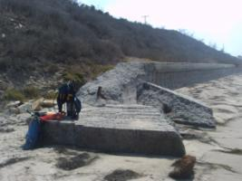

Figure 10: Tajiguas during summer Figure 11: Tajiguas during winter

A noticeable difference in the amount of fines in sediment samples taken from different depths can be observed. Sediment samples I took from the zone once occupied by a kelp bed in Goleta Bay contained fine silt particles not found in samples of beach sand taken from the intertidal zone (Fig. 12). The samples taken from -30 feet contained more fines than those taken from -50 feet. This indicates minimal lateral shifting of sediment within these depths.

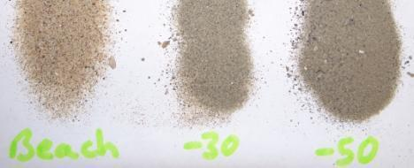

Figure 12: Sediment Samples

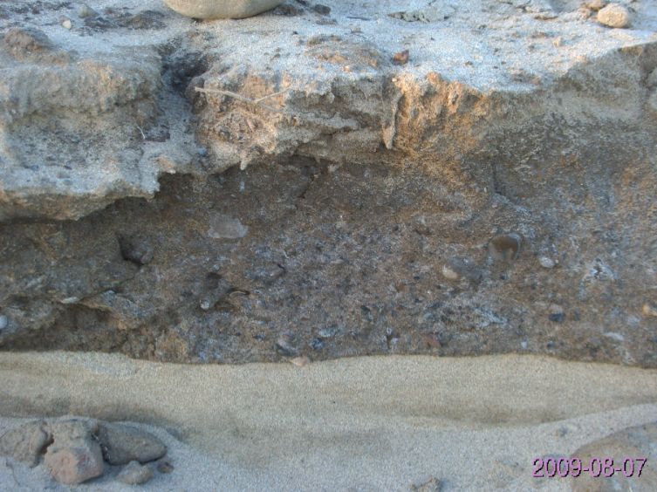
Sediment dredged from Atascadero Creek was deposited on the west end of Goleta Beach during the spring of 2009. Within a few months, much of the sediment washed away revealing a stratification consisting of naturally sorted sediment over the dirt layer placed atop the original beach sand (Fig. 13). Dirt clumps and rocks were scattered throughout the area.
Rocks on the beach are a byproduct left behind from sediments dredged from local area creeks. They tend to stay behind and create a rocky intertidal zone after the other sediments are washed away (evident in the pictures below (Fig’s. 14 & 15). This could be considered an undesirable consequence to barefoot beach-goers in a location like Goleta Beach, where naturally-deposited sediment would be primarily beach-quality sand.
Figure 13: Stratification of Beach Fill, August 7, 2000

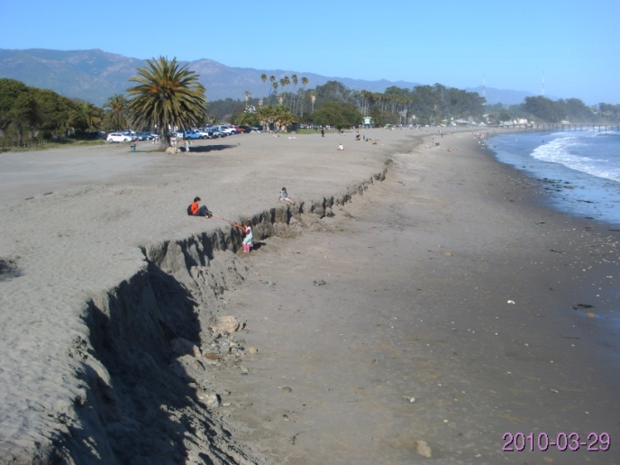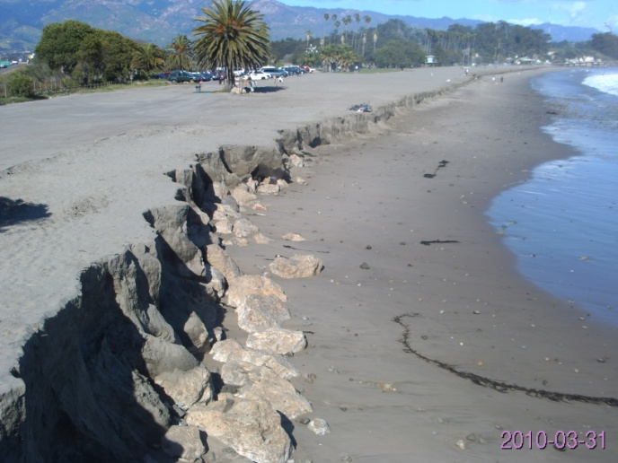

Figures 14 & 15: Dredged Fill, March 29, 2010 (left) and March 31, 2010 (right)

Sediments dredged from offshore and creeks contain fine silt particles. When these sediments are used for beach nourishment, they produce ‘dusty’ beach sand when dried. This is evident from the fill added to the beach in March, 2010 (Fig’s. 14 & 15).
Placing fill on the beach alone will not address the erosion problem long-term. This is evident from the pictures above taken 3 days apart (Fig’s. 14 & 15). In order for the beach to naturally widen, the water depth in the nearshore subtidal zone must be decreased to allow for the diffusion of wave energy. This is only going to be produced by either hard substrate not capable of being moved, or through natural processes causing sediments to accrete offshore as well as onshore.
A wide beach protects the backshore region from exposure to the erosive effects of storm surges by acting as a self-renewing buffer. Widening of the beach in Goleta Bay through natural processes would be preferable to the often undesirable and costly methods used in beach nourishment, which generally yields only short-term results. From the time Goleta Beach County Park was constructed in 1946 until 1982, the balance of forces at work in Goleta Bay resulted in the formation of a wide beach inside the bay. Since the disappearance of the kelp bed in the early 1980’s, the change in these forces is apparent through the chronically narrow state of the beach. Restoring a kelp bed offshore could conceivably be the anecdote for treating the cause.

Possible Kelp Bed Influence
The idea of reestablishing a kelp bed offshore of Goleta Bay as a means of addressing the beach erosion problem inside the bay was rejected by the planning committee (Goleta Beach Master Planning Process) on the basis that kelp beds have little known effect on the attenuation, deflection, or refraction of large, low-frequency gravity swells. Nonetheless, kelp beds are effective at altering higher-frequency wind-generated capillary waves and current. Although subtle, these are the forces acting on the shoreline the majority of the time.
Current (most commonly generated by wind) varies in direction and velocity, and is often present within the littoral zone. Although the current is generally not strong enough to move the subtidal sediment, these sediments are made available for transport when lifted off the seafloor by surge and the effects of turbulence associated with passing swells. In localities where the current is subdued and wave energy is relatively low, sediment is deposited onto the beach through wave and tidal action, and the beach is widened over time. Due to the size and location of the kelp bed that once existed offshore of Goleta Bay prior to 1982, it is plausible it altered the coastal currents in a manner favorable to the formation of a wide beach.
I have encountered current on a number of different occasions when diving off Goleta Point and within the historical kelp bed zone. The velocity of the current varied proportionately with wind speed. In 2005, I made a (crude) model of Goleta Bay to examine the possible influence this (primary) wind-generated current might have on the body of water east of Goleta Point.

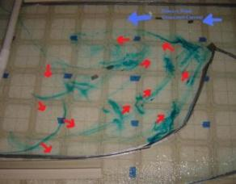
The physical model (Figure 16) produces a slow and continuous flow of water moving ‘eastward’ past ‘Goleta Point’. This is indicative of wind-generated current (indicated by the blue arrows). Dye drops added to the water at various locations diffused into bands as they were stretched when carried by current. The red arrows show the direction the dye moved, revealing a secondary counterclockwise eddy current formed inside the bay. Note the confluence of the two currents at the Point and the resulting means for transporting sediment offshore. A large kelp bed is likely to deflect the wind-generated current moving past Goleta Point and create a boundary of resistance between this current and the water inside the bay, effectively shutting down the mechanism presently controlling sediment transport and deposition.

Figure 16: Model of Goleta Bay

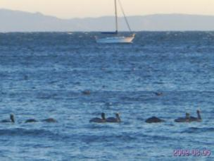
On different occasions over the past few years, when wind was blowing ‘down’ the channel (from a westerly or southwesterly direction), I’ve noticed flocks of birds resting in the same area offshore of Goleta Bay. I took the above photo (Figure 17) on such an occasion in August 2009 from the bluff by UCSB (there are a number of smaller birds not as easy to see in the picture just behind the pelicans in the foreground). Even though wind was blowing from a southwesterly direction across the bay at the time, the birds did not appear to be drifting downwind. It appears the birds settled in a location where the wind force and water movement were balanced, allowing the birds to remain stationary.

Figure 17: Birds Resting Inside Goleta Bay

Kelp Bed Establishment Prior to 1982
Giant Macrocystis kelp has been successful at establishing itself along vast stretches of sand substrate offshore of the Santa Barbara Channel mainland coastline, producing an almost continuous band of kelp until the early 1980’s (Fig. 3, Page 3).
Oceanic conditions are favorable for the growth of kelp along the California coastline the majority of the time. Periodic conditions resulting in low nutrients and high water temperature are short-lived, and the physical condition of the kelp tends to recover in a relatively short period of time once normal conditions return.
The geography of the region plays a significant role in the ability of sand-dwelling kelp beds to become established. The east-west orientation of the coastline and the existence of the Channel Islands offshore, provide protection of the shoreline from storm swells approaching from most directions.
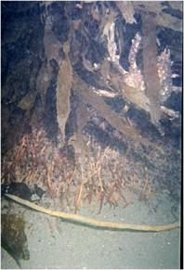
The tenuous anchoring system of juvenile kelp plants on sand bottom requires mild conditions for an extended period of time to allow the holdfasts to grow large. Succeeding generations of kelp plants recruiting onto the holdfasts of older plants build up the anchoring system. Sediment shifting on the seafloor from surge (produced by passing swells) fills the voids within the holdfast structures producing an effective anchor (Fig. 18). The holdfasts eventually become large enough that they can endure larger swells. These growth-centers become the basis for the formation of the sand-dwelling kelp beds.

Figure 18: Holdfast on Sand Bottom
Note sand filling holdfast voids and spider crab.

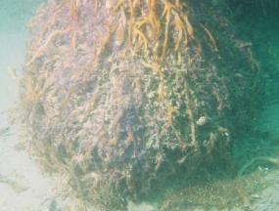
I have also encountered Sandcastle worms (Phragmatopoma californica) colonizing holdfasts growing on sand (Fig. 16). These marine polychaetes form honeycomb-like structures by cementing sand grains together, which may also contribute to growth-center formation.
As the density and width of the kelp beds grow, so too does their influence on shoreline processes shaping the beaches. In the decades prior to 1982, the establishment of sand-dwelling kelp beds in Santa Barbara County coincided with the formation of wider beaches than are seen today along some areas of the coastline.

Figure 19: Sandcastle Worms Colonizing Holdfast
Note the purple tentacles of the worms protruding from the structure.

Kelp Disappearance in Early 1980’s

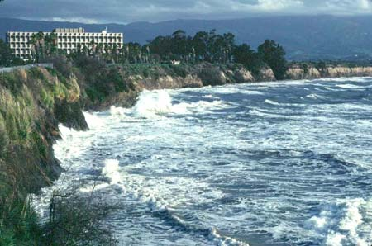
Elevated water temperatures from a developing El Niño in 1982 compromised the health of kelp plants in southern California. Severe storm activity associated with this event during the winter months, resulted in the dislodgement of most of the kelp plants along the Santa Barbara Channel mainland coastline (Fig. 20). Slow recovery of the kelp beds occurred over the following years, but only in areas where rocky reef substrate exists.

Figure 20: UCSB beach, January 26, 1983
High tide in the morning during El Nino storm.
Photo by Dr. Arthur Gibbs Sylvester
Future episodic storm events will occur. How long it takes for the beach to recover afterwards is dependent upon coastal processes. Restoring a kelp bed of historical proportions in Goleta Bay may alter these processes in a manner favorable to the formation of a wide beach. Successfully accomplishing this on sand bottom is the challenge.

Sand-Dwelling Macrocystis Kelp
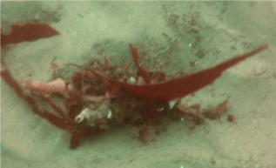
The process by which kelp plants anchor themselves to sand-bottom, and the resulting formation of large sand-dwelling kelp beds, has a weak link in the early stages of development. In the sand bottom regions offshore once occupied by sand-dwelling kelp beds, worm tubes (Diopatra ornata) are for the most part the only surfaces stable enough for kelp plants to recruit and grow on (Fig’s. 21 & 22). It is the fragile nature of this recruitment source coupled with the sand substrate upon which to grow, however, that prevents the juvenile plants from growing to maturity (Fig. 23).

Figure 21: Diopatra ornata Worm Tube
It is common to see algae pieces adhered to the worm tubes; possibly for camouflage, or a means of storing food.

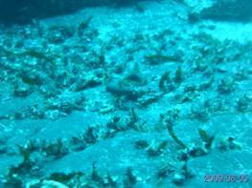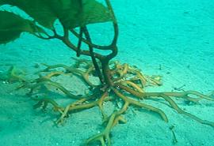

Figure 23: Juvenile Sand-Dwelling Macrocystis Kelp Plant
Note the haptera: the root-like projections of the holdfast. This plant is growing on a Diopatra ornate worm tube.

Figure 22: Diopatra Congregating
Clusters of Dioptra are common between reefs, such as this photo taken at Anacapa Island shows.

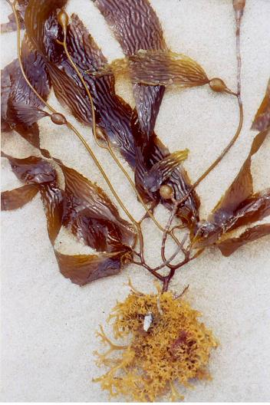
The inherent buoyancy and drag of the kelp plants increase as the fronds grow upward toward the surface, eventually exceeding the holding capability of the holdfasts on the sand. The plants finally pull up away from the sand and the worm tubes break, sending the plants adrift (Fig. 24).
During the summer months, juvenile kelp plants can be found in abundance on local area beaches. The substrate which these plants grew on can be determined by examining the underside of the holdfasts. A remnant of Diopatra worm tube at the center of the holdfast indicates the plant was growing on sand bottom. Close inspection of this worm tube will reveal fragments of shell and other particles adhered to the worm tube casing (Fig. 25). Most likely a means of armoring the exposed portion of the worm tube, these fragments provide surfaces for kelp spores to settle on. The close proximity of the resulting (male and female) gametophytes allows for effective fertilization to occur and the eventual growth of a kelp (sporophyte) plant.

Figure 24: Young Sand-Dwelling Kelp Plant on Beach.
Note remnant of worm tube in holdfast.

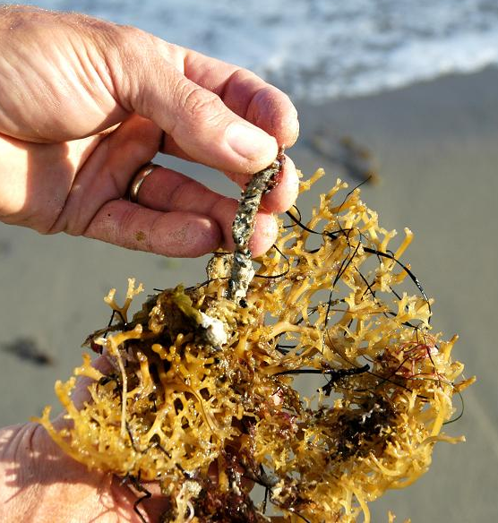

Figure 25: Young Macrocystis Holdfast with Remnant of Diopatra ornata Worm Tube

While performing investigative dives over the last few years in areas once occupied by sand-dwelling Macrocystis kelp beds (including in Goleta Bay) I noticed Diopatra tube worms were relatively scarce in most areas, which is understandable since Diopatra worms eat algae. The few kelp plants I did find growing on other structures in the sand had numerous Diopatra congregating at the perimeter of the holdfasts. These colonizing Diopatra may contribute to growth-center development in some manner.

Optimal Zone of Sand-Dwelling Kelp Beds
The optimal zone for the natural recruitment and growth of kelp within each area is apparent by observing the well-defined boundaries of the surface canopy. With often no change in bottom morphology, other factors influence where these boundaries lie.
The ratio of plant size and growth rate to holdfast size and growth rate are likely factors in establishing the outer boundary of the sand-dwelling kelp beds. Kelp plants along the coast will grow to depths of 70 feet or more in areas containing solid substrate, where sunlight penetration appears to be the limiting factor. Along adjacent sand bottom areas, however, the kelp plants seem to have a maximum depth range of about 50 feet. Beyond this depth it is likely the plants reach a critical size relative to the holding capability of the plants on sand. The amount of fines in the seafloor sediment may inhibit growth-center formation as well.
The inner boundary of the sand-dwelling kelp beds is likely established at the depth and proximity to shore where shifting seafloor sediment occur. This depth is approximately 30 feet in Goleta Bay.

Investigative Dives in Goleta Bay
I performed survey dives within the zone once occupied by a sand-dwelling kelp bed in Goleta Bay in April, 2007. Using SCUBA with ‘Dive-Link’ voice communication and dive sleds, we were towed by a boat following lines of longitude, bisecting the zone from the outer to inner boundaries of the historical kelp bed.

Link to Video Survey:

A typical video survey along longitude 119° 49.836W, between the outer boundary (latitude 34° 24.278N) and inner boundary (latitude 34° 24.540N) can be viewed by going to the following link: http://www.youtube.com/watch?v=b35vQQfs9A0

One notable finding on dives performed in Goleta Bay over the years was the number of golf balls found on the seafloor. A likely source of the golf balls is from the Sandpiper golf course, which lies ~ 5.5 miles to the west. If an eddy current is indeed a common occurrence within the bay, it would explain the accumulation of golf balls, which were likely transported there from wind-generated current moving eastward along the coastline.
While diving in Goleta Bay over the years, I observed benthic marine life to be relatively scarce, even among the eelgrass (Zostera marina) found in water depths less than ~ 45 feet. Restoring a sand-dwelling kelp bed within the bay is likely to benefit its ecology, primarily through the restoration of giant kelp habitat.

Proposed Strategy for Reestablishing Sand-Dwelling Kelp Beds
The presence of the Diopatra ornata tube worms combined with years of mild swell activity, are likely to be key factors influencing the past establishment of sand-dwelling kelp beds. Unless conditions are optimal for an extended period of time, regeneration of these beds to pre-1982 conditions through natural processes is unlikely to occur anytime soon. Even if reestablishment of the kelp beds were to occur, they would remain susceptible to becoming dislodged during future El Niño events. Providing supplemental structures for kelp plants to recruit and grow on within the optimal zone for sand-dwelling kelp beds, could aid in the restoration of the kelp beds and help ensure their long-term survival.
Various methods for growing kelp on artificial anchors have been tried in the past, but they all have undesirable side-effects associated with them. To maximize the likelihood for long-term success, I used the following criteria in developing this proposed strategy:
- Cost: Economical with potential payback
- Deployment: Method must have minimal impact on existing marine life
- Fabrication: Capable of being mass-produced in a timely and cost-effective manner
- Feasibility: Doable on a large scale
- Fisheries: No negative impacts
- Handling: Accounts for ease of handling, transport and deployment
- Location: Placed within the zone best suited to sand-dwelling kelp beds
- Longevity: Last indefinitely with no chance of creating a problem for future generations
- Low-profile: Minimal exposure above seafloor
- Recruitment: Allows for the natural recruitment and growth of kelp plants without the need for transplanting
- Stability: Stays put under all conditions once set in place
- Spacing: Account for the natural spacing and formation of growth-centers
- Sturdiness: Withstand handling and the forces acting on them once set in place
- Subsidence: Not affected by surge
- Toxicity: Harmless to marine life and the environment
- Volume: Use the least amount of material as possible
The anchoring system I am proposing is designed to meet all the above performance standards.
The delicate nature of the worm tubes appears to be the primary factor in preventing the natural recovery of sand-dwelling kelp beds along the Santa Barbara Channel mainland coastline. Supplementing the worm tubes with more-substantial structures would likely increase the chances for recovery of the beds in the area. However, due to the depth of sediment in offshore areas (such as Goleta Bay) within the optimal depth zone for establishing growth-centers on sand bottom, and the effects of scouring, objects placed on the seafloor will eventually subside and disappear. Large boulders and piles of rocks placed on the seafloor would generally not fully-subside, but the amount of material and cost would be prohibitive on a large scale.
Water-jetting granite columns (measuring 36”x 2”x 2”) into the seafloor, leaving 4-6 inches of column exposed above the seafloor, meets the criteria mentioned above (Figs. 26 & 27). The exposed granite nodes (being more-substantial than worm tubes) would enable the growing plants to grow to the surface (where photosynthesis is optimized) without becoming dislodged. As the holdfasts grow down and over the seafloor, and compound in size, sediment will collect within the voids of the holdfast structures anchoring the plants to the seafloor (Fig. 28).
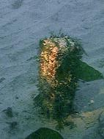
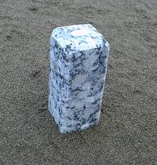
Figure 26: Exposed Granite Node

Figure 27: Exposed Granite Node with Algae

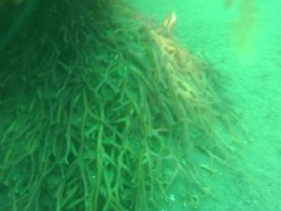

Figure 28: Holdfast Growing on Sand Bottom
Note the growing haptera on the outside of the holdfast structure. Diopatra congregating around the holdfast can be seen in the photo as well.
Perimeter scouring will occur around the holdfasts during periods of higher surge. The growing haptera (root-like projections of the holdfasts) will bend downward into the resulting depressions formed around the perimeter of the holdfasts. As this process occurs periodically, a portion of the holdfasts could conceivably become buried beneath the normal plane of the seafloor, increasing the anchoring capability of the plants. The developing growth-centers would become the foundations for succeeding generations of kelp plants to grow on. Large numbers of growth-centers within close proximity to one another will eventually form a sand-dwelling kelp bed.
Placing the proposed granite columns on ~ 20 foot centers should provide an adequate spacing for maximizing kelp canopy coverage within a given area. Kelp plants developing on worm tubes will likely occur as well as Diopatra are drawn to the area by the presence of kelp. Kelp plants growing in close proximity to one another are likely to alter the localized environment in ways favorable to the continued growth and survival of the plants within the bed. The performance of this method as a means for establishing sand-dwelling kelp beds can be examined by performing a pilot study.

Proposed Pilot Study

Purpose
- Demonstrate the ability to recruit and grow Macrocystis kelp on sand bottom.
- Assess if proposed method is suitable for a future large-scale project.
- Determine if seafloor sediment depth changes seasonally within the nearshore area east of Goleta Point, within the zone once occupied by a sand-dwelling Macrocystis kelp bed.

Scope
Set 200 granite columns (measuring 2”x 2”x 36”) ~ 30 inches into the seafloor east of Goleta Point in three different sites within the zone once occupied by a sand-dwelling Macrocystis kelp bed. Total volume of (fill) material = .617 cubic yard. Survey dives will be performed at each site at least twice per year (or as required) for up to 3 years. Reports will be submitted within 1 month of each survey and will include pictures. I would like to leave the columns in place indefinitely to continue monitoring their performance over time. In the event the columns are ordered to be removed, I will do so by using a water-jetting wand to free the columns. The columns would then be recycled for landscaping or road fill.
Site 1 (Primary): Consists of 142 columns set 10 feet apart along longitude 119° 49.925’W, between latitudes 34° 24.497’N and 34° 24.265’N. An additional 30 columns will be set 20 feet apart alongside the east side of this line to form a 100’ x 100’ (10,000 sq-ft) grid at the center of the main line. Total number of columns = 172.
Site 2: Consists of 14 columns set 10 feet apart, from latitude 34° 24.333’N running southward along longitude 119° 50.360’W.
Site 3: Consists of 14 columns set 10 feet apart, from latitude 34° 24.227’N running southward along longitude 119° 50.488’W.
The columns set at sites 2 and 3 will be used to test for seasonal changes in sediment depth in the nearshore area east of Goleta Point.
Preliminary and post-deployment underwater video surveys of each site will be performed. Additional post-deployment surveys will be conducted at specified intervals.
If available, cultured juvenile kelp plants will be tied to ~ 25% of the columns with jute line, or attached with rubber bands, to expedite plant growth for the purpose of reducing the timeframe for evaluating growth-center formation.

Method
The 142 granite columns set inline in site 1 will be lowered to the seafloor by clipping them 10 feet apart to a line payed-out from a boat moving along longitude 119° 49.925’W, between latitudes 34° 24.497’N and 34° 24.265N. The additional 30 columns will be set on 20 foot centers in a 10,000 square-foot plot (100 feet by 100 feet) adjacent to and east of the center of the line of columns.
The columns will be water-jetted into the seafloor by a diver (using SCUBA or hookah). A gas-powered pump on the boat supplies seawater to a 1 inch diameter hose, 75 feet long. The other end of the hose is connected to a valve on the end of a water-jetting wand. The columns will be set into the sediment to a depth of 30-32 inches, leaving 4-6 inches of granite protruding from the seafloor. The deployment line aids the diver in locating the columns and will be removed after the columns are set.
The 14 granite columns set inline in site 2 will be lowered to the seafloor by clipping them 10 feet apart to a line payed-out from a boat moving southward along longitude 119° 50.360’W, from latitude 34° 24.333’N.
The 14 granite columns set in-line in site 3 will be lowered to the seafloor by clipping them 10 feet apart to a line payed-out from a boat moving southward along longitude 119° 50.488’W, from latitude 34° 24.227’N.

Link to Video showing water-jetting test in Goleta Bay:
The following link shows video of water-jetting testing performed in Goleta Bay: http://www.youtube.com/watch?v=CNKWzkYbQws
A ¾” diameter hose and wand was used, which proved to be slightly under-sized, to check sediment depth and experiment with setting a granite column. The column was removed after testing.
An observation worth noting is the presence of a shell layer I encountered just beyond ~ a foot or so under the seafloor. I was able to water-jet through this layer without too much difficulty.

Hypotheses to be tested
- A diver (with SCUBA or hookah) using the water-jetting method described will be capable of setting a 36 inch long granite column to the desired depth into the seafloor within 30 seconds.
- The columns will remain indefinitely as originally placed.
- Kelp spores will settle and develop naturally on the exposed granite nodes protruding from the seafloor.
- The exposed granite nodes will support the growth of kelp when placed within the ideal depth zone.
- Kelp plants growing on the granite nodes will reach the surface within one year when oceanic conditions are normal.
- Growth-centers will develop at each granite node as the holdfasts grow onto and over the seafloor. The voids within the holdfasts will fill with sediment, which becomes the means by which each growth-center anchors to the seafloor.
- This benign method for growing kelp on sand bottom will enrich the marine ecosystem without any adverse impacts.

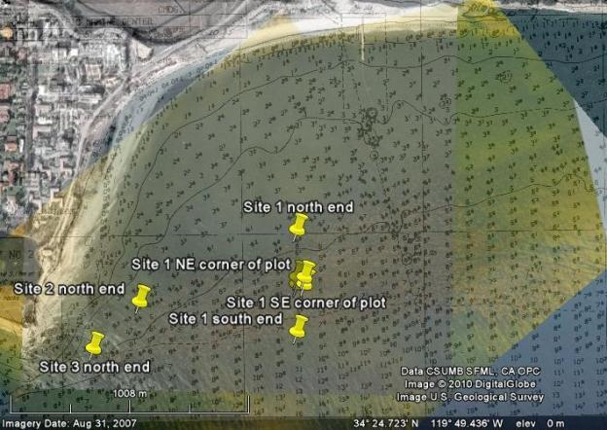

Figure 29: Google Earth Image with 1972 and 1975 Overlays
The historical kelp bed and proposed pilot study test site markers are shown. The boundaries of the kelp bed shown in each of the two overlays line up, which qualifies accuracy. The transparency of the overlays has been adjusted to reveal the present-day image as well. The following can be performed when viewed in Google Earth:
- Zooming in on the image reveals all the center (10,000 sq-ft) plot markers
- GPS coordinates of any spot can be obtained by moving the curser to the desired location and reading the displayed latitude and longitude values
- Measurements can be taken
- The three overlays and test site markers can be switched on and off independently
- Historical images can be obtained dating back to 1994
If Google Earth is loaded on your computer and this report is viewed as a Word document (not PDF), click on the link below once, and then double-click on the KMZ file icon to open this image on Google Earth. Click on the boxes and menu items to the left of the image in ‘Places’ to switch the various images (1972 aerial photo overlay, Kelco 1975 photo overlay, hydrographic chart overlay and test site markers) on and off. All the features of Google Earth found in the tool bar at the top (historical images, measuring, zooming in/out) can be used on this image. The GPS coordinates of any point can be obtained by moving the curser over the point and reading the latitude and longitude values at the bottom.

Google Earth Link
To download Google Earth (for free), go to: http://www.google.com/earth/download/ge/agree.html

Future Large-Scale Project
If the pilot study performs favorably, the method can be used in a future large-scale project to reestablish a kelp bed of historical proportions in Goleta Bay. This could conceivably alter the hydrodynamics of the bay in a manner resulting in the eventual reformation of a wide beach through natural processes. A self-renewing wide beach will create a buffer to help protect Goleta Beach County Park from winter storm surges.
A kelp bed extending 1.25 miles (6,600 feet) eastward from the west end of the historical bed, with an average width of .27 miles (1,426 feet), would cover an area of 216 acres (9,411,600 sq-ft). Covering this area with a kelp bed of optimal density would require 23,832 columns placed on 20 foot centers. At a cost of $20 per column, the total cost of columns needed would be ~ $500,000. The total volume of columns (fill material) = 73.56 cubic yards (< 100 tons).
Assuming a diver could set 50 columns per hour (once the columns are lowered onto the seafloor); it would take ~ 500 single-diver hours to set all 23,832 columns. With a diver actively setting columns for 6 hours per day (shared between two or more divers), it would take ~ 80 diving days to set all the columns.
A more precise budget and time estimate could be determined after a few lines of columns are set, but it appears this project could be completed at a reasonable cost. Considering the potential longevity of the columns and the resulting benefits to the ecosystem and shoreline, the return on this investment over time would likely prove to be substantial.

Justifications for Reestablishing a Kelp Bed Offshore of Goleta Bay
- Possible ‘soft’ solution for addressing the erosion problem along the shoreline:
Tests hypothesis that an offshore kelp bed can alter coastal processes in a favorable manner, which allows for the natural sorting and transport of sediments delivered to the coastline and the accretion of beach-quality sediments along the shore.
Negates the need for costly and invasive alternatives such as recurring beach nourishment, rock revetments, managed retreat through the relocation of park infrastructures, and beach stabilization through the construction of groins: all of which treat only the symptoms of beach erosion.
- Environmentally Enriching:
Creation of kelp forest habitat in relatively barren sand bottom areas. The proposed method allows for rapid recovery of the kelp bed if it were to be dislodged again from a future episodic event. A wide beach would also enable terrestrial plants to grow on the more-stable backbeach.
- Test feasibility of cultivating kelp for commercial use:
Kelp can be harvested directly as a feed source for abalone. Abalone farms help supply the global demand for abalone through commercial cultivation. Large-scale commercial cultivation could conceivably reduce fishing and poaching pressures of wild stocks.
Kelp can also be harvested and processed to extract alginates used for thickening, stabilizing, suspending, gelling and emulsifying agents in industrial products, pharmaceuticals and food additives.
A more recent use for giant kelp is in the production of the biofuel butanol through bacterial fermentation.
- Scientific study:
The close proximity of UCSB to Goleta Bay offers a unique opportunity for future research.

Each on these justifications could stand alone as valid reasons to restore a kelp bed in Goleta Bay.

Conclusion
There are numerous justifiable reasons for restoring sand-dwelling Macrocystis kelp beds. The method used to do so, however, must meet a myriad of criteria in order for there to be any reasonable chance of success. Performing a pilot study to examine the proposed method outlined in this report is essential for determining the feasibility and possible degree of success of such an undertaking.

The economic and recreational benefits Goleta Beach has to offer justify the study, refinement, and implementation of systems to protect it. The empirical evidence supporting the idea that a correlation exists between the beach width and an offshore kelp bed in Goleta Bay is compelling. Considering the controversy, time and money spent to date on addressing the erosion problem plaguing Goleta Beach County Park, it would be prudent to pursue establishing a sand-dwelling Macrocystis kelp bed in Goleta Bay.

Acknowledgements
I extend my sincerest appreciation to the following individuals and agencies: my wife Kelley, and my children Justin and Jessie for putting up with me and my endeavor to research and develop this proposal; Greg Christman for dive support and contributing in the taking and editing of pictures; Dr. Arthur Gibbs Sylvester for permitting me to use some of his pictures; Jeff Phillips for volunteering the use of his boat, and assisting with survey dives; Fred Hepp for contributing his time and boat for research dives in Goleta Bay; Craig Barilotti, Dale Glantz, Dan Reed, Bruce Harger, and Hany Elwany for taking time to consult with me and provide pertinent information; my colleagues at work for their support and contributions; John Anderson for editing; B.E.A.C.O.N. and Santa Barbara County Parks for supporting me in my pursuit of this project; the support and contributions from the many businesses I contacted; and everyone who takes the time to read this proposal and consider its implementation.

References

Books
Abbott, I. and Hollenberg, G. 1976. “Marine Algae of California.” Stanford University Press.
Bascom, Willard. 1980. “Waves and Beaches.” Anchor press/Doubleday.
Connor, J. and Baxter, C. 1972. “Kelp Forests.” Monterey Bay Aquarium Foundation.
Davis, Richard A. 1978. “Coastal Sedimentary Environments.” Springer-Verlag, New York Inc.
Doty, M.S., J.F. Caddy and B Santelices 1986 (eds.). “Case Studies of Seven Commercial Seaweed Resources.”
FAO Fish.Tech.Pap., (281).
Druehl, L. 2000. “Pacific Seaweeds.” Harbour Publishing.
Gotshall, Daniel. 1994. “Guide to Marine Invertebrates.” Sea Challengers.
King, C.A.M. 1972. “Beaches and Coasts.” Edward Arnold Publishers, LTD.
Kampion, Drew. 1989. “The Book of Waves.” Roberts Rhinehart Publishers.
Komar, Paul D. 1976. “Beach Processes and Sedimentation.” Prentice-Hall, Inc.
O’Clari, R.M. and Lindstrom, S.C. 2000. “North Pacific Seaweeds.” Plant Press.
Rickets, Calvin, Hedgpeth, revised by Phillips, David. 1994. 5th Edition. “Between Pacific Tides.” Stanford University Press.
Waaland, R. 1977. “Common Seaweeds of the Pacific Coast.” Pacific Search Press.

Papers
Beach Erosion Authority for Clean Oceans and Nourishment. http://beacon.dst.ca.us/index.htm
Benavides, Steve. 1998. “What Happened to the Kelp in Southern California?”
Bird, K.T. and Benson, P.H. 1987. “Seaweed Cultivation for Renewable Resources.” Chaper 3. Neushul, M. and
Harger, B. 1987. “Nearshore Kelp Cultivation, Yield and Genetics.” Elsevier Science Publishers.
California Coastal Act.
California Coastal Coalition. “Public Beach Restoration Program.”
California CoastKeeper Alliance. 2002. “Regional Kelp Restoration – Project Restoration and Monitoring Protocol.”
California Department of Boating and Waterways and State Coastal Conservancy. 2002. “California Beach Restoration Study.”
California Department of Fish and Game. 1990. “Artificial Reef Plan for Sport Fish Enhancement.”
Elwany, H. and Flick, R. 1996. “Relationship Between Kelp Beds and Beach Width in Southern California .”
Journal of Waterway, Port, Coastal and Ocean Engineering. Vol. 122, No. 1.
Elwany, O’Reilly, Guza and Flick. 1995. “Effects of Southern California Kelp Beds on Waves.” Journal of
Waterway, Port, Coastal and Ocean Engineering. Vol. 121, No. 2.
Jackson, George A., 1984, “Internal Wave Attenuation by Coastal Kelp Stands.”
Jackson, George A.., 1997, “Currents in the High Drag Environment of a Coastal Kelp Stand off California.”
Goleta Beach Master Planning Process (and related links). www.Sbparks.org/goletabeach/edflyer/p02.htm
Interdisciplinary Oceanography Group. D. Reed, L. Washburn and P. Raimondi. “Kelp Spore Dispersal.”
Kelco Report to California Department of Fish and Game. 1991. “Santa Barbara Kelp Restoration Project.” Contract # FG-0322.
Moffat and Nichol Engineers. 2002. “Goleta Beach County Park Long-Term Beach Restoration and Shoreline Erosion Management Final Plan.”
Ocean Resources Management Program. 2003. “Draft Review of California Coastal Erosion Planning and Response: A Strategy for Action.” California Resources Agency. Http://ceres.ca.gov/cra/ocean
“Seaweed Cultivation for Renewable Resources”, edited by K.T. Bird and P.H. Benson, Elsevier Science Publishers B.V., Amsterdam, 1987, Chapter 3, “Nearshore Kelp Cultivation, Yield and Genetics”, Neushul and Harger
Sylvester, Arthur G. “UCSB, Goleta, and Isla Vista Beaches.” Sylvester@geology.ucsb.edu
“Test-Farming of the Giant Kelp Macrocystis as a Marine Biomas Producer”, 1983, Harger and Neushul
The California North County Times. 1997. Johnson, Christina S. “The great kelp forests are vanishing: Orange County was first; Can North County be far behind?”
“The California Environmental Quality Act.”
Santa Barbara News-Press. Assorted articles.
Beach Erosion Authority for Clean Oceans and Nourishment. http://beacon.dst.ca.us/index.htm
Carr, Mark. “Macrocystis Ecology, Evolution, Morphology, Reproduction.” www.biology.ucsc.edu/people/raimondi/readdie/ecology.htm
Coastal Community Network. “Kelp Farming.” www.coastalcommunity.bc.ca/html/newslett/issue2article5.htm
“El Nino and La Nina.” www.ispe.arizona.edu/climas/learn/swnutshell/tlsd005.htm
“ISP (International Specialty Products) Alginates Overview.” 2000.
www.ispcorp.com/products/alginates/overview.html
“Kelp Forest Ecology Species List.” www.biology.ucsc.edu/classes/biol61/KFE%2001%species%201ist.htm
“Kelp Forest Facts.” Monterey Bay National Marine Sanctuary Office. www.birdingbyboat.org/kelp.htm
“Modern and Paleo Climate Records.” www.ualr.edu/~erse/oceanography/enso/page5.htm.
NOAA National Marine Sanctuaries – Science and Education. “Kelp Habitat.”
www.sanctuaries.los.noaa.gov/scid/science/habitat/kelp_descriptions.html
“PPT Slide – Long-term Cycles and Shifts.” www.ispe.arizona.edu/climas/learn/swnutshell/tlsd011.htm
Rourke, Mary. 2002. “Wheeler North, 80: Helped Save Kelp Beds.” “Kelp Reforestation Project.” www.coastkeeper.org/kelp.html
“The Pacific Decadal Oscillation.” 2000. http://tao.atm05.washington.edu/pdo/

Contacts

Agencies Contacted
Army Corps of Engineers:
- Coastal Engineering Research Center (CERC) 601-634-3044. Thomas Richardson, Nicholas Kraus, Joan Pope (Research and Development Center, 601-634-3034)
- Seattle: Eric Nelson, 206-764-3557
- Ventura (Regulatory Office): David Castanon, 805-585-2141
- John (Jack) Malone, 805-585-2146
- Los Angeles (Civil Works Office): Tony Risco, 213-452-3789
B.E.A.C.O.N:
- Kevin Ready, 805-662-6890
- Karl Treiberg, (SB Flood Control) 805-568-3443
- Gerald Comati, 805-962-0488, cell-805-895-0255, Gerald@com3consulting.com
California Coastal Commission:
- Headquarters office: Shana Gray, 805-585-1800
- South Central District Office, Ventura: Melanie Hale, 805-585-1800
- San Francisco: Nancy Cave and Sharone Assa, 415-904-5298
- Alison Dettmer (415-904-5205), Marina Cazorla and Tom Luster (415-904-5249)
City of Goleta:
- Ken Curtis, 805-961-7540 (7500)
- Michael Bennett, Councilmember, 805-961-7535
Coastal Conservancy, 510-286-1015
California Department of Boating and Waterways:
- Kim Sterrett, 916-263-8157
California Department of Fish and Game:
- Marine Region: Marilyn Fluharty, 858-467-4231
- Offshore Ecosystems: Marija Voikovich, 805-568-1246
- Commercial Fisheries: Dave Thomas, 510-581-7358
- Recreational Fisheries: Steve Crooke, 562-342-7195
- John O’Brian, 562-342-7173
- Dennis Bedford, 562-342-7172
- Santa Barbara office: Ken Willson and David Ono, 805-568-1221
California State Lands Commission (Sacramento):
- Jane Smith, 916-574-1892
- Dwight Sanders, 916-574-1880
- Barbara Dugal, 916-574-1833
- Mary Hays, 916-574-1812
Santa Barbara County Board of Supervisors: 805-568-2191
- Susan Rose
- Rachel Couch
- Lisa Hummer
Santa Barbara County Parks:
- Terri Maus-Nisich 805-568-2461 (Past)
- Coleen Lund, 805-568-2470 (Past)
- Erik Axelson, 805-681-5651 (Recent)
- Juan Beletrana, 805-568-2470 (Recent)
State Regional Water Quality Control Board:
- Lisa McCann, 805-549-3132
US Coast Guard:
- Jerry Johnson, 510-437-2982 (2968)
US Department of Fish and Wildlife:
- Dan Buford, 916-414-6625
US National Marine Fisheries:
- Rodney McInnis, 562-980-4000

Businesses Contacted
Allied Hole Hogs: 216-373-0244
American Rope: 800-227-7673
California Coastkeeper Alliance: 310-548-0983. Chantal Collier
Coastal Environments: 858-459-0008. Hany Elwany
Coastal Resources: 760-603-0612
Cold Springs Granite: 800-328-5010
Earth Consultants Inc.: 425-643-3780
Environmental Defense Council: 805-963-1622. Brian Trautwine
Globe Machine Manufacturing: 253-383-2584. Vic Croston
Goleta Building Materials: 805-967-5413. Ken Hall and John
Goleta Sanitary District: 805-967-4519
Improved Construction Methods: 800-877-4571. Jimmy Buzby
Industrial Vibration Products: 401-539-2392
International Specialty Products (ISP) Alginates: Dale Glantz (Biologist) 619-557-3194
InterNet Inc.: 800-328-8456. John Krause
Kelp Forest Society: 949-721-9006. Rudolphe Streichenberger
Laird Plastics: 206-623-4900. Jeff Dallen
Neushul Mariculture: 805-964-5844. “Sunnyside Sea farms.” Bruce Harger
NSWW Aquaculture Products: 800-368-3610. Hunt Ozmer
Pacific Western Aerials Surveys: 805-963-0382. Michael Kambitsch
Poly-Hi (UHMW plastic manufacturer): 360-885-1141. Dan
Rockwell Automation: 425-746-2840. Ken Roche
Sacramento Bag: 800-287-BAGS. Chris Marr
Samson Rope Technologies: 800-227-7673
Santa Barbara Channelkeeper: 805-563-3377. Jessica Altstatt, Michael Sheehy
Seattle Marine and Fishing Supply: 206-285-5010
Surfrider Foundation: 805-899-2583. Brian Keats
TerraSystems Inc. (Wick Drains): 540-882-4130. John Jones and Dave Panich
The Chandlery (West Marine): 800-262-8464
The Cultured Abalone: 805-685-1956. Dick Creig
Wacker – High Frequency Internal Vibrators: 510-222-9790
Williams Form Engineering Corporation (Manta Ray mechanical soil anchors): 800-344-6728

Personal Contacts
Available upon request.

Personal Contact Information
Robert Kiel – Author and Principle Investigator
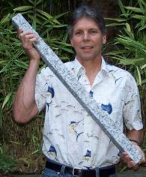
kiels@comcast.net

206-244-5154 (home)
206-954-7258 (cell)

Address:
3306 SW 112th Place
Seattle, WA 98146

