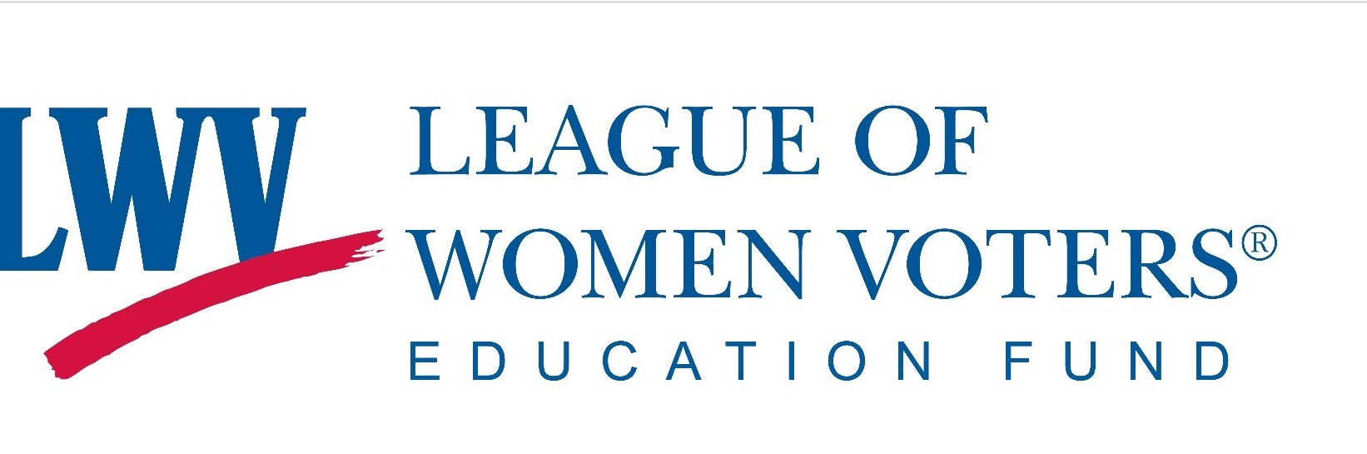

PRESS RELEASE

League of Women Voters of Santa Barbara
Education Fund
Contact: Susan Horne
805-962-2415
Publicity: Jane Benefield
805-684-6086
League of Women Voters Public Forum
OCTOBER 9, TUESDAY, 6 PM
Faulkner Gallery, at the SB Public Library
40 Anapamu, Santa Barbara

FORUM TO DISCUSS PROS/CONS OF ALL STATE PROPOSITIONS
AND LOCAL BALLOT MEASURES
NOVEMBER 6 BALLOT

The League of Women Voters of Santa Barbara and the Education Fund of the League will moderate a forum to discuss the state ballot propositions and the local ballot Measures on the November 6 State of California General Election Ballot.

All eleven state measures will be discussed along with local measures affecting Santa Barbara City and County, including county redistricting and charter amendments.

Simultaneous Spanish translation will be available.
Parking is next to the library and handicapped parking is accessible on Anacapa Street (Granada Parking lot)
SBTV will video the forum for later viewing on Channel 17.
SBTV and the SB Public Library are co-sponsors of this event.

